Groundsperson

CANDIDATE PACK
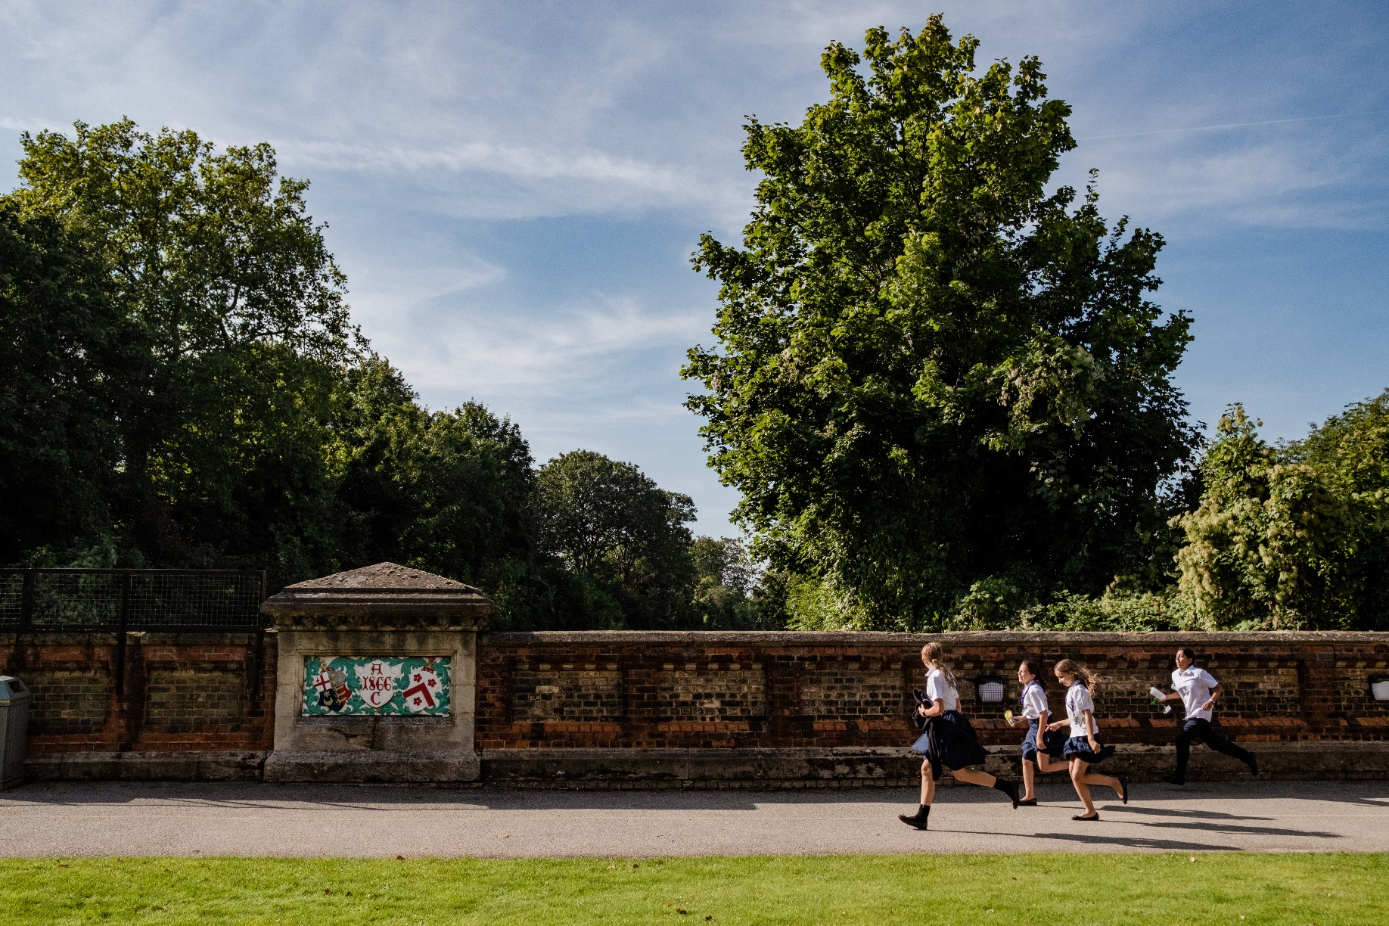
Groundsperson
Are you driven and passionate about creating a safe but welcoming environment for young people? If so, our Grounds Department at JAGS is looking for a colleague to join them.
The Grounds team at JAGS are responsible for maintaining and developing over 22 acres in South London across 2 sites as well as a commercial Sports Club. The school offers a wide array of sporting activities including athletics, hockey, football, cricket and the team work closely with the relevant teams to ensure the facilities are maintained and always beautifully presented.
With its distinctive heritage as the oldest independent girls’ school in London, James Allen’s Girls’ School, JAGS, provides a forward-thinking and contemporary education for over 1000 girls aged 4 to 18.
A diverse and dynamic school community that nurtures self-assured and considerate individuals who thrive, JAGS has entered an exciting new phase in its development.
This post presents a great opportunity to work within a community without barriers to full participation. Your input will help to support the school’s bold vision for all pupils and colleagues as we work together to develop this already exceptional school in its next exciting chapter.

James Allen’s Girls’ School 144 East Dulwich Grove London SE22 8TE
groundsperson
message from the head
I am delighted that you are interested in joining the JAGS community. As Head, it’s absolutely my belief that all girls should be given the opportunity to grow and flourish in an environment where there is no limit to their ambitions.
At JAGS you will find a happy, diverse and dynamic community, rooted in academic excellence and yet fully committed to the breadth of a holistic education both in and out of the classroom. Compassion and commitment are central to our ethos, in this environment that values individuality and inclusivity.
Our school aims, both in and out of the classroom, are clear:
- To celebrate our diverse and inclusive community
- To champion social awareness and sustainability
- To empower courage, creativity and compassion in each student
- To inspire aspirational and authentic lifelong learners and leaders
- To nurture respectful, resilient and kind individuals

It is an enormous privilege to lead this exceptional school, where all members of our school community share a passion for life and learning.
I hope that this matches your educational vision, and look forward to welcoming you soon.
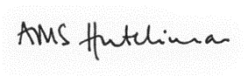

MRS ALEX HUTCHINSON, MA (OXON) PGCE

James Allen’s Girls’ School 144 East Dulwich Grove London SE22 8TE
groundsperson
working at jags
Working at JAGS is about more than just working. JAGS is a community and a family that nurtures a warm and supportive environment for both the students and staff who come to learn and work here. From your first day at JAGS you will have access to some of the best educational facilities in the country and will be encouraged to take part in the many shared activities here.

JAGS works hard to attract the best staff and the benefit package is both generous and competitive.
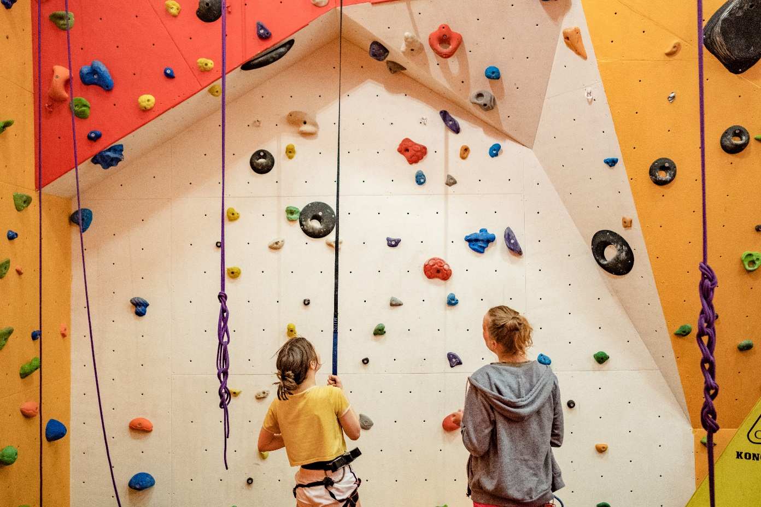

We offer you:
- The opportunity to join our outstanding school where public examination results consistently place JAGS amongst the leading schools in the UK
- A community of creative and compassionate students and staff
- A highly diverse and inclusive school community, committed to our bursary provision
- An inspiring and enthusiastic team of colleagues across the teaching and support staff
- Excellent facilities, including the latest resources to support learning
- Up to 10% Employer contribution to the School pension scheme
- A wide-ranging benefit package including lunch, free gym membership, school fee discount, cycle to work scheme, availability of computer staff loan, contribution to cost of eye tests and glasses, free access to the Dulwich Picture Gallery, death in service benefit

James Allen’s Girls’ School 144 East Dulwich Grove London SE22 8TE
Groundsperson

THE ROLE
Job Title: Groundsperson (Skilled)
Terms & Conditions: Full Time (all year round) 35 hours per week
8am to 4pm (with 1-hour unpaid lunch break)
Salary: FTE Salary - £24000 - £30000
Responsible to: Head Groundsperson
Overview
The role focusses on maintaining the sports field, all weather surface and tennis hardcourts.
Main responsibilities
- Maintaining the sports field, all weather surface and tennis hardcourts to a high standard.
- Using a variety of machinery including Tractors, Tractor mounted equipment, Ride on mowers, Pedestrian mowers, and a variety of handheld equipment.
- End of season renovation work. Including Top dressing, seeding, and fertilising.
- Marking out sports pitches. Football, Cricket, Athletics track and other track and field events.
- Keeping all school areas tidy. Jobs including emptying bins, collecting rubbish, sweeping playgrounds and paths.
- Ensure that all aspects of both the School Health & Safety Policies are adhered to.

Groundsperson
PERSON SPECIFICATION
Essential | Desirable
Education/Knowledge/Work Experience
- Previous experience of working within a similar environment.  - Level 2 or above in Turf Culture.  - Good knowledge of using all types of Grounds machinery. | - First Aid Certificate or willingness to undertake first aid training  - Previous experience of working within a school  - Level 3 in Turf Culture or equivalent.
Skills
- Ability to build effective working relationships
- Good interpersonal skills and ability to communicate and work with all levels of staff/colleagues within the School.
- Good written and verbal communication skills.
- Strong attention to detail.

Personal Behaviours
- Kindness, open-mindedness and a sense of humour
- Resilience and optimism; someone who is willing to go the extra mile in the busy life of the school
- Team-working abilities and a keenness to enable all colleagues to contribute ideas and be part of positive change
- Integrity, diligence and conscientiousness
- Flexibility and pragmatism
- Extremely high standards in all aspects of professional conduct (including attendance and punctuality).

Ethos & Whole School Values
- An individual with a genuine commitment to the wellbeing of the staff and students
- Committed to operating as part of the School community
- Committed to diversity, inclusion and anti-racism in the School community
- Committed to sustainability

Safeguarding
- Committed to safeguarding and promoting the welfare of children and young people
- A satisfactory Enhanced Disclosure from the DBS

Groundsperson
HOW TO APPLY
We welcome applications from all parts of our community and know that our school is strengthened when staff and pupils feel a true sense of belonging. To enable us to make any reasonable adjustments, please let us know when you submit your application whether you have any special requirements.
Please visit our website http://www.jags.org.uk/about/employment to download a JAGS Support Staff Application Form. For further information please contact recruitment@jags.org.uk or James Allen’s Girls’ School, 144 East Dulwich Grove, London SE22 8TE
Closing date: 23/05/2022
Interviews: w/b 30/05/2022
Applications will be reviewed daily and interviews may occur at any stage after applications are received so we invite interested candidates to apply as soon as possible by submitting their completed application form to recruitment@jags.org.uk
JAGS is committed to the safeguarding and welfare of children and applicants must be willing to undergo child protection screening appropriate to this post, including checks with past employers, the Disclosure and Barring Service and overseas police check if necessary. Candidates from overseas must provide information about their past conduct, for example, by providing documents issued by overseas teaching authorities.

James Allen’s Girls’ School 144 East Dulwich Grove London SE22 8TE

