School Counsellor
(Fixed Term)

CANDIDATE PACK
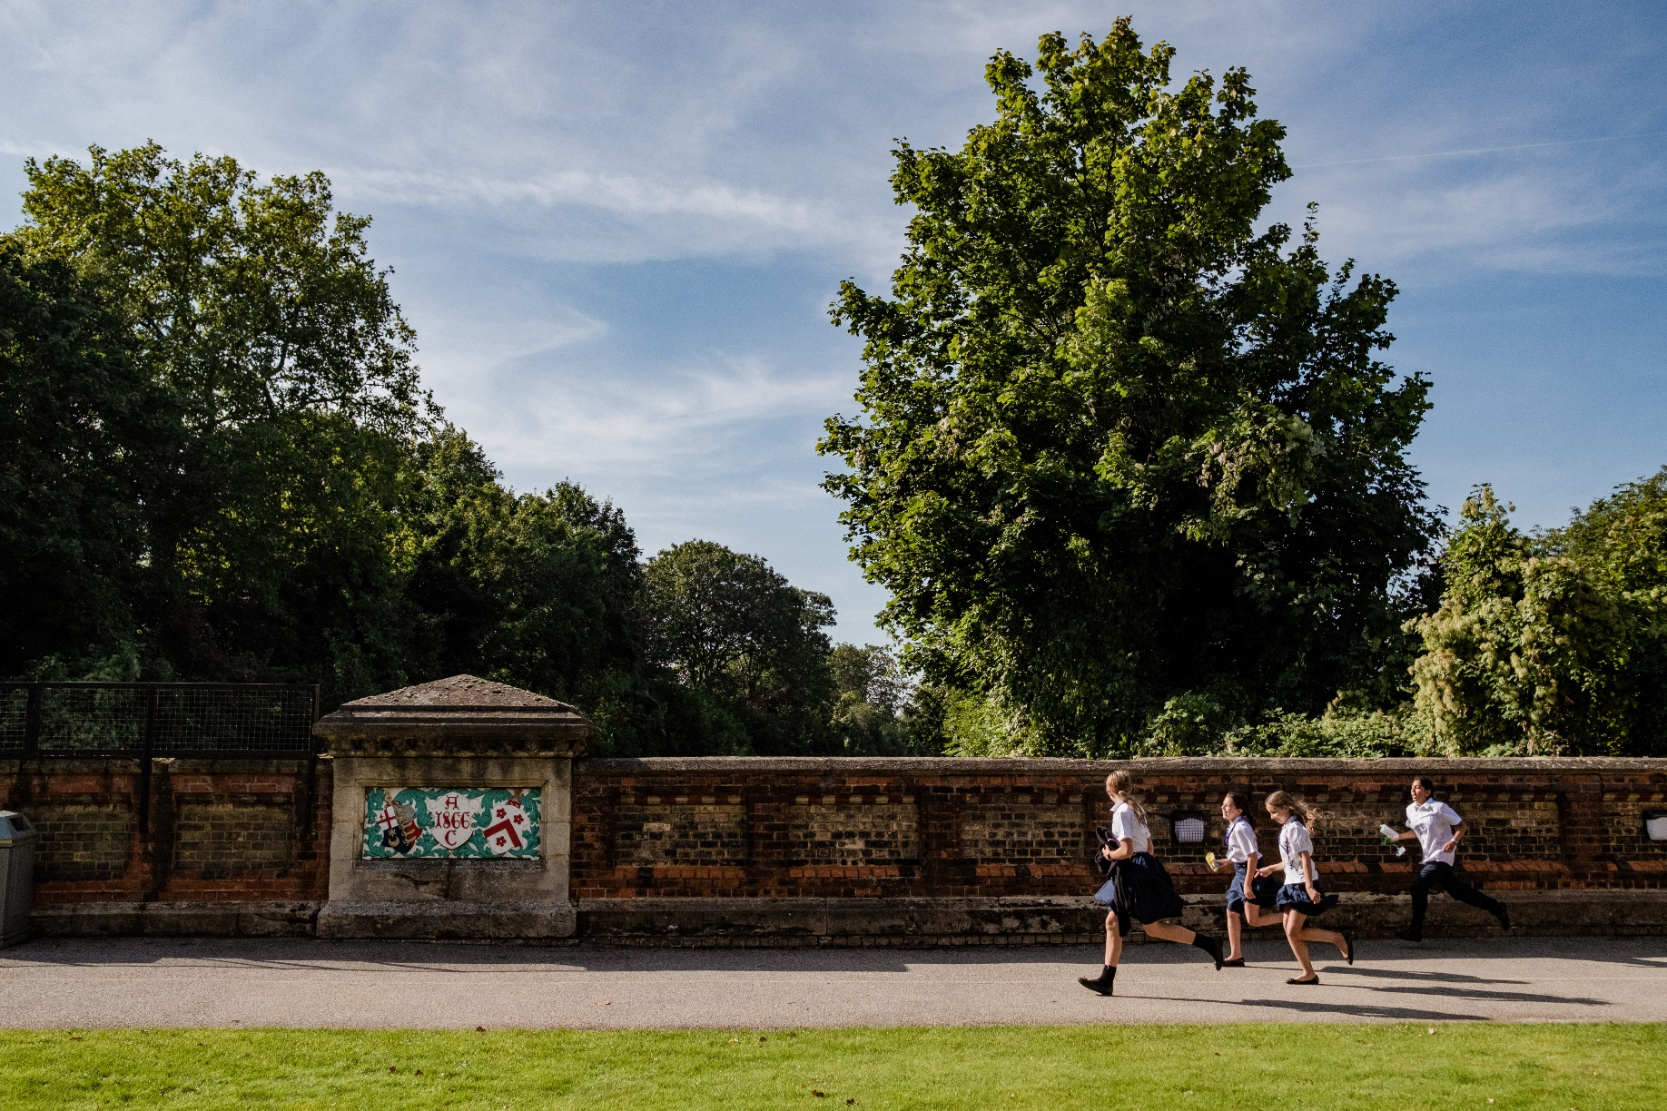
counsellor (FIXED TERM)
Are you driven and passionate about creating a safe but welcoming environment for young people? If so, our pastoral team at JAGS is looking for a colleague to join them.
With its distinctive heritage as the oldest independent girls’ school in London, James Allen’s Girls’ School, JAGS, provides a forward-thinking and contemporary education for over 1000 girls aged 4 to 18.
A diverse and dynamic school community that nurtures self-assured and considerate individuals who thrive, JAGS has entered an exciting new phase in its development.
This post presents a great opportunity to work within a community without barriers to full participation. Your input will help to support the school’s bold vision for all pupils and colleagues as we work together to develop this already exceptional school in its next exciting chapter.

James Allen’s Girls’ School 144 East Dulwich Grove London SE22 8TE
counsellor (FIXED TERM)
message from the head
I am delighted that you are interested in joining the JAGS community. As Head, it’s absolutely my belief that all girls should be given the opportunity to grow and flourish in an environment where there is no limit to their ambitions.
At JAGS you will find a happy, diverse and dynamic community, rooted in academic excellence and yet fully committed to the breadth of a holistic education both in and out of the classroom. Compassion and commitment are central to our ethos, in this environment that values individuality and inclusivity.
Our school aims, both in and out of the classroom, are clear:
- To celebrate our diverse and inclusive community
- To champion social awareness and sustainability
- To empower courage, creativity and compassion in each student
- To inspire aspirational and authentic lifelong learners and leaders
- To nurture respectful, resilient and kind individuals

It is an enormous privilege to lead this exceptional school, where all members of our school community share a passion for life and learning.
I hope that this matches your educational vision, and look forward to welcoming you soon.
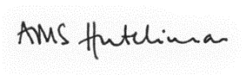

MRS ALEX HUTCHINSON, MA (OXON) PGCE

James Allen’s Girls’ School 144 East Dulwich Grove London SE22 8TE
counsellor (FIXED TERM)
working at jags
Working at JAGS is about more than just working. JAGS is a community and a family that nurtures a warm and supportive environment for both the students and staff who come to learn and work here. From your first day at JAGS you will have access to some of the best educational facilities in the country and will be encouraged to take part in the many shared activities here.

JAGS works hard to attract the best staff and the benefit package is both generous and competitive.
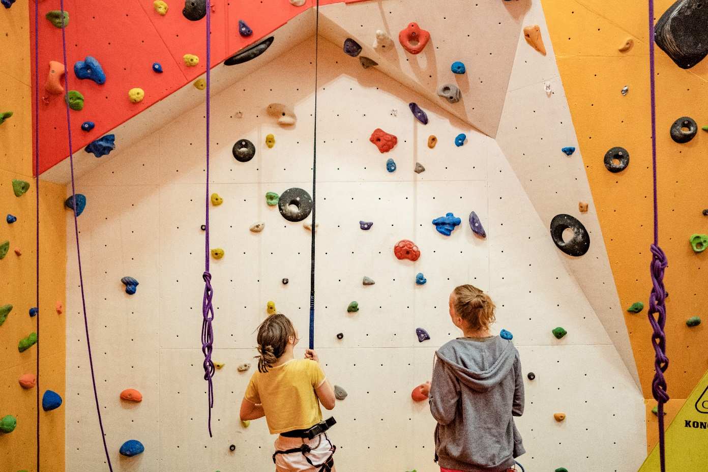

We offer you:
- The opportunity to join our outstanding school where public examination results consistently place JAGS amongst the leading schools in the UK
- A community of creative and compassionate students and staff
- A highly diverse and inclusive school community, committed to our bursary provision
- An inspiring and enthusiastic team of colleagues across the teaching and support staff
- Excellent facilities, including the latest resources to support learning
- Up to 10% Employer contribution to the School pension scheme
- A wide-ranging benefit package including lunch, free gym membership, school fee discount, cycle to work scheme, availability of computer staff loan, contribution to cost of eye tests and glasses, free access to the Dulwich Picture Gallery, death in service benefit

James Allen’s Girls’ School 144 East Dulwich Grove London SE22 8TE
Counsellor (FIXED TERM)

THE ROLE
Job Title: Counsellor (Fixed Term)
Terms & Conditions: 8am - 5pm Term time – 33 weeks @ 3.5 days x 8 hours a day (Mon, Weds, Thurs am and Friday)
Non-term time – 13 weeks @1.5 days x 8 hours a day
Salary: FTE Salary - £32,000 - £45,000
Responsible to: Deputy Head, People
Overview
The role focusses on providing one to one counselling to pupils, maintaining appropriate records and liaising regularly with the School Nurses, Deputy Head (People) and the wider school Pastoral team and other professionals as necessary.

Main responsibilities
- To provide counselling service to pupils at JAGS, (Junior and Senior School) through individual sessions, responding to their personal, social, emotional or educational concerns
- To promote a caring and supportive environment where such concerns may be explored, thereby promoting the mental and emotional health at JAGS
- To maintain confidentiality (except in those circumstances, in line with BACP practice, where this should be breached)
- To uphold good practice as described by the BACP ethical guidelines
- To be responsible for their own Professional Development maintenance and updating knowledge and awareness through Continuing Professional Development (CPD)
- To make referrals, where appropriate and with the pupil’s and parents’ consent, to other agencies, participating and leading in joint assessments with other agencies and providing reports for referrers, families and the school
- To liaise, where appropriate and with the pupil’s consent, with members of staff including the Deputy Head, People the Designated Safeguarding Lead, Heads of Section and Heads of Year, the Deputy Head, Pastoral Junior School, SEND coordinators and another school counsellor
- To maintain appropriate records and to keep these secure, also recording relevant details on the school’s CPOMS system
- To liaise with school staff and other professionals as appropriate to ensure the effective operation of the service
- To be alert to trends and patterns of welfare concerns and to be willing to identify causes and recommend supportive action, basing interventions on NICE guidelines and evidence-based practice
- To play an active role in Safeguarding children and adhere to school policies
- To maintain a high level of knowledge and awareness of changes and developments in the fields of counselling and education and their impact on the delivery of counselling
- To ensure that as a Counsellor they are properly and regularly supervised, as required by the BACP/HCPC, the name and address of the supervisor to be supplied on request to the Deputy Head (People)
- To contribute in any other reasonable fashion to promote the safety and wellbeing of the pupils
- Such other duties associated with the above tasks as may be reasonably required
- To provide relevant information via the Deputy Head People in advance of pastoral meetings
- To attend meetings or discussion sessions with parents if asked and as appropriate within the agreed confidentiality guidelines above

counsellor (FIXED TERM)
PERSON SPECIFICATION
Essential | Desirable
Education/Knowledge/Work Experience
- Previous experience of working within a similar environment  - Relevant Counselling qualification at Diploma or above  - Member of BACP/HCPC  - At least 2 years post qualification experience as a practising therapist or counsellor with School and Multi Agency experience. | - Previous experience of working within a school  - Further relevant qualifications  - Professional research experience
Skills
- Ability to build effective working relationships
- Proven ability to communicate effectively with young people.
- Awareness of network of children’s services and experience of multi-agency inter-professional work
- Experience of group work with young people
- Awareness and understanding of mental health issues
- Good interpersonal skills and ability to communicate and work with all levels of staff/colleagues within the School
- Good written and verbal communication skills
- Strong attention to detail
- Competent at using computer and Microsoft applications i.e. Outlook, Word

Personal Behaviours
- Kindness, open-mindedness and a sense of humour
- Resilience and optimism; someone who is willing to go the extra mile in the busy life of the school
- Team-working abilities and a keenness to enable all colleagues to contribute ideas and be part of positive change
- Integrity, diligence and conscientiousness
- Flexibility and pragmatism
- Extremely high standards in all aspects of professional conduct (including attendance and punctuality)
- Readiness to seek help and support to manage professional issues and problems

Ethos & Whole School Values
- An individual with a genuine commitment to the wellbeing of the staff and students
- Committed to operating as part of the School community
- Committed to diversity, inclusion and anti-racism in the School community

Safeguarding
- Committed to safeguarding and promoting the welfare of children and young people
- A satisfactory Enhanced Disclosure from the DBS

Counsellor (FIXED TERM)
HOW TO APPLY
We welcome applications from all parts of our community and know that our school is strengthened when staff and pupils feel a true sense of belonging. To enable us to make any reasonable adjustments, please let us know when you submit your application whether you have any special requirements.
The Deputy Head (People) Paul.ODwyer@jags.org.uk will be happy to answer any questions.
Please visit our website http://www.jags.org.uk/about/employment to download a JAGS Support Staff Application Form. For further information please contact recruitment@jags.org.uk or James Allen’s Girls’ School, 144 East Dulwich Grove, London SE22 8TE
Closing date: Monday 23 May 2022
Interviews: Thursday 26 May 2022
Applications will be reviewed daily and interviews may occur at any stage after applications are received so we invite interested candidates to apply as soon as possible by submitting their completed applicationyy form to recruitment@jags.org.uk
JAGS is committed to the safeguarding and welfare of children and applicants must be willing to undergo child protection screening appropriate to this post, including checks with past employers, the Disclosure and Barring Service and overseas police check if necessary. Candidates from overseas must provide information about their past conduct, for example, by providing documents issued by overseas teaching authorities.

James Allen’s Girls’ School 144 East Dulwich Grove London SE22 8TE

